**Create an Animation**

Below is a screenshot of the first animation.



Here is a photo of it being played back on a laptop computer with an external 1080p display.

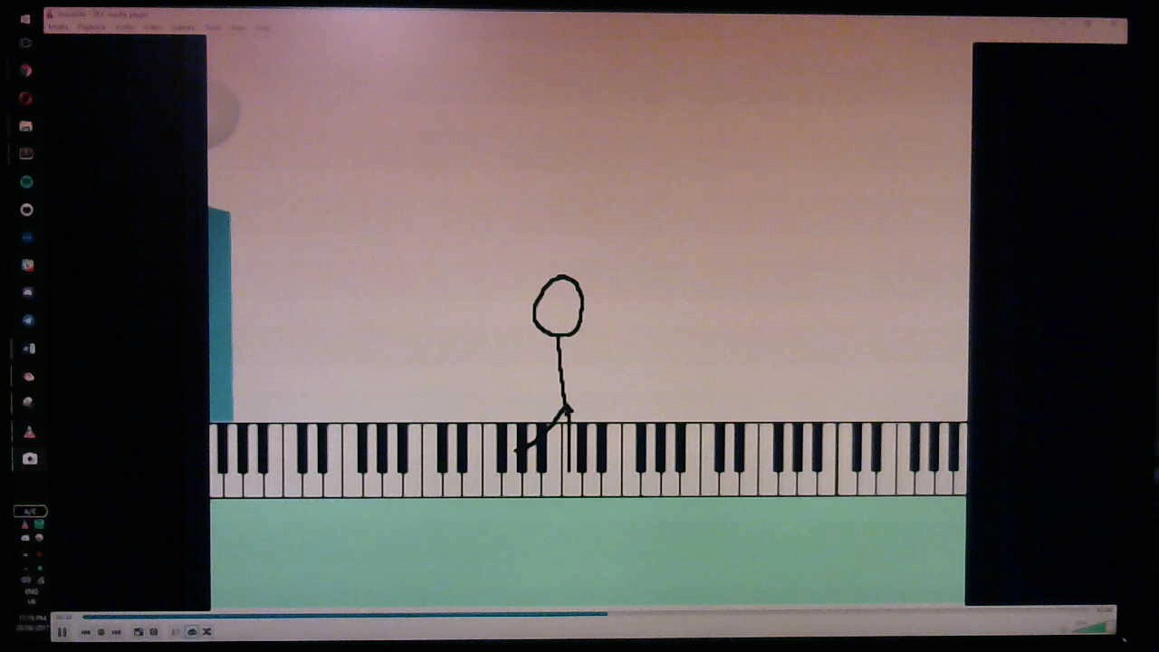

The video played back smoothly at the same framerate it was recorded in.

Here is a photo of the video being played back on a mobile phone.

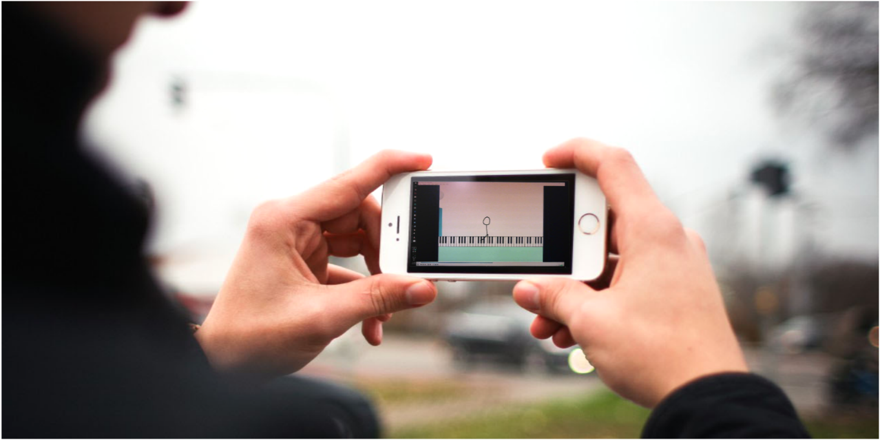

Once again, the video played back smoothly.

Below is a screenshot of the second animation

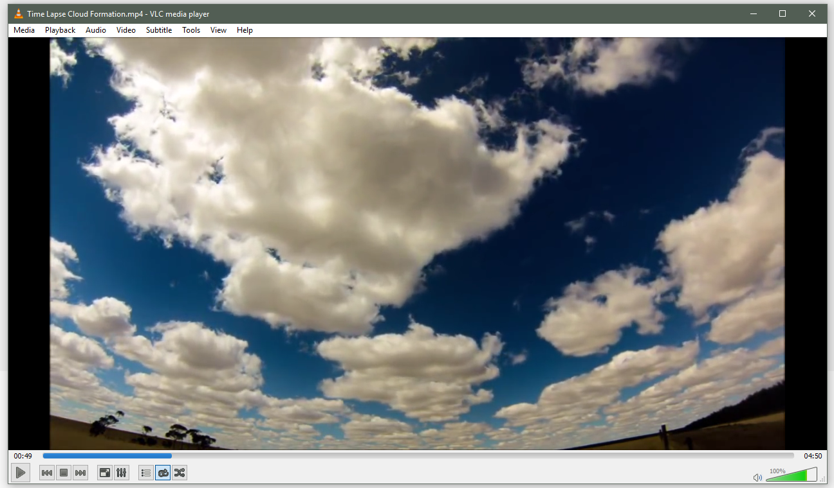

I preformed the same test on the laptop with an external display, and mobile phone.

